### **MySQL MCQs**

1. **Which of the following is a MySQL command to view the current databases?**
   * a) SHOW DATABASES;
   * b) DISPLAY DATABASES;
   * c) LIST DATABASES;
   * d) VIEW DATABASES;
2. **What is the correct command to create a new database in MySQL?**
   * a) CREATE NEW DATABASE db_name;
   * b) CREATE DATABASE db_name;
   * c) NEW DATABASE db_name;
   * d) MAKE DATABASE db_name;
3. **Which command is used to delete a database in MySQL?**
   * a) DELETE DATABASE db_name;
   * b) REMOVE DATABASE db_name;
   * c) DROP DATABASE db_name;
   * d) ERASE DATABASE db_name;
4. **How do you select all columns from a table named 'users'?**
   * a) SELECT ALL FROM users;
   * b) SELECT * FROM users;
   * c) SELECT FROM users;
   * d) SHOW * FROM users;
5. **Which of the following is used to add a new column to an existing table?**
   * a) ADD COLUMN table_name column_name column_type;
   * b) ALTER TABLE table_name ADD COLUMN column_name column_type;
   * c) MODIFY TABLE table_name ADD column_name column_type;
   * d) INSERT COLUMN table_name column_name column_type;
6. **What is the command to delete rows from a table based on a condition?**
   * a) REMOVE FROM table_name WHERE condition;
   * b) DELETE FROM table_name WHERE condition;
   * c) ERASE FROM table_name WHERE condition;
   * d) CLEAR FROM table_name WHERE condition;
7. **Which SQL statement is used to update data in a table?**
   * a) MODIFY table_name SET column_name = value WHERE condition;
   * b) CHANGE table_name SET column_name = value WHERE condition;
   * c) UPDATE table_name SET column_name = value WHERE condition;
   * d) EDIT table_name SET column_name = value WHERE condition;
8. **Which keyword is used to sort the results of a query?**
   * a) ORDER BY
   * b) SORT BY
   * c) GROUP BY
   * d) ARRANGE BY
9. **How can you limit the number of rows returned by a query?**
   * a) LIMIT number;
   * b) RESTRICT number;
   * c) ROWS number;
   * d) COUNT number;
10. **Which function is used to count the number of rows in a table?**
    * a) SUM()
    * b) COUNT()
    * c) TOTAL()
    * d) NUMBER()
11. **What is a primary key?**
    * a) A column that uniquely identifies each row in a table
    * b) A column that can contain duplicate values
    * c) A column used to establish relationships between tables
    * d) A column that always has a default value
12. **Which MySQL statement is used to create a table?**
    * a) NEW TABLE table_name (columns);
    * b) ADD TABLE table_name (columns);
    * c) CREATE TABLE table_name (columns);
    * d) MAKE TABLE table_name (columns);
13. **What does the 'NULL' value represent in MySQL?**
    * a) Zero
    * b) Empty string
    * c) Missing or undefined value
    * d) A space character
14. **Which SQL clause is used to filter records?**
    * a) FILTER
    * b) WHERE
    * c) HAVING
    * d) LIMIT
15. **How do you rename a table in MySQL?**
    * a) RENAME table_name TO new_table_name;
    * b) ALTER TABLE table_name TO new_table_name;
    * c) MODIFY TABLE table_name TO new_table_name;
    * d) CHANGE TABLE table_name TO new_table_name;
16. **Which operator is used to check for a specified pattern in a column?**
    * a) LIKE
    * b) MATCH
    * c) PATTERN
    * d) SEARCH
17. **What is the purpose of the GROUP BY clause?**
    * a) To sort data
    * b) To filter data
    * c) To group rows that have the same values in specified columns into summary rows
    * d) To limit data
18. **How do you combine rows from two or more tables, based on a related column?**
    * a) MERGE
    * b) JOIN
    * c) LINK
    * d) COMBINE
19. **Which command is used to remove a column from a table?**
    * a) DELETE COLUMN column_name FROM table_name;
    * b) REMOVE COLUMN column_name FROM table_name;
    * c) DROP COLUMN column_name FROM table_name;
    * d) ERASE COLUMN column_name FROM table_name;
20. **Which clause is used to filter the results set after grouping?**
    * a) WHERE
    * b) HAVING
    * c) GROUP BY
    * d) FILTER
21. **What is the correct syntax for a MySQL INSERT statement?**
    * a) INSERT INTO table_name (columns) VALUES (values);
    * b) ADD INTO table_name (columns) VALUES (values);
    * c) INSERT table_name (columns) VALUES (values);
    * d) ADD table_name (columns) VALUES (values);
22. **Which of the following is true about foreign keys?**
    * a) They uniquely identify each row in a table
    * b) They enforce a link between the data in two tables
    * c) They allow duplicate values
    * d) They always have a default value
23. **What does the DISTINCT keyword do?**
    * a) It selects all unique values
    * b) It sorts the results
    * c) It groups the results
    * d) It filters the results
24. **Which MySQL function is used to calculate the average value of a numeric column?**
    * a) SUM()
    * b) COUNT()
    * c) AVERAGE()
    * d) AVG()
25. **How do you select all columns from a table named 'customers' where the 'age' is greater than 30?**
    * a) SELECT * FROM customers WHERE age > 30;
    * b) SELECT ALL FROM customers WHERE age > 30;
    * c) SELECT * FROM customers HAVING age > 30;
    * d) SELECT ALL FROM customers HAVING age > 30;
26. **Which MySQL command is used to delete a table?**
    * a) DROP TABLE table_name;
    * b) DELETE TABLE table_name;
    * c) REMOVE TABLE table_name;
    * d) ERASE TABLE table_name;
27. **What does the AUTO_INCREMENT attribute do?**
    * a) Automatically inserts a null value
    * b) Automatically inserts a unique value
    * c) Automatically inserts a zero value
    * d) Automatically inserts the previous row's value
28. **Which MySQL data type is used to store large text?**
    * a) TEXT
    * b) VARCHAR
    * c) CHAR
    * d) STRING
29. **How do you create a stored procedure in MySQL?**
    * a) CREATE PROCEDURE proc_name AS BEGIN ... END;
    * b) NEW PROCEDURE proc_name AS BEGIN ... END;
    * c) ADD PROCEDURE proc_name AS BEGIN ... END;
    * d) MAKE PROCEDURE proc_name AS BEGIN ... END;
30. **What is the command to display the structure of a table?**
    * a) SHOW TABLE table_name;
    * b) DESCRIBE table_name;
    * c) EXPLAIN table_name;
    * d) VIEW TABLE table_name;

### **MySQL Exercises**

1. **Create a database named library.**



1. **Create a table named books with columns id, title, author, and published_year.**



1. **Insert three records into the books table.** 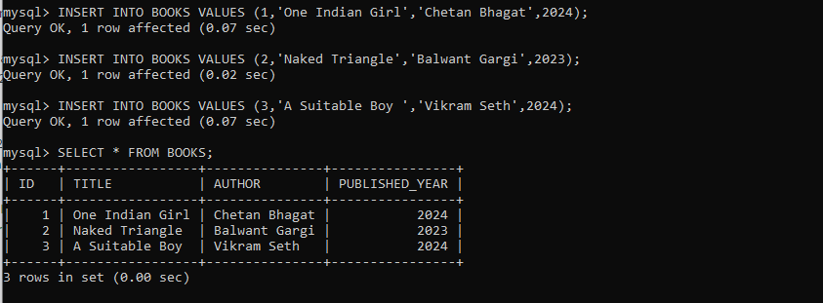
2. **Update the author of the book with id 1 to 'George Orwell'.**

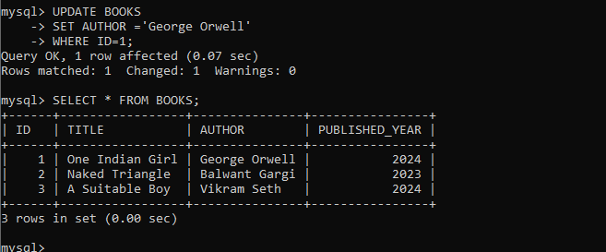

1. **Delete the book with id 3 from the books table.**

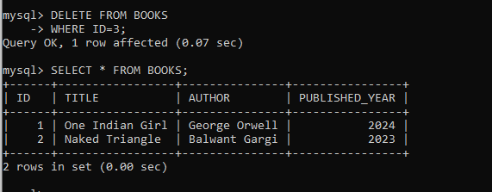

1. **Select all columns from the books table.**

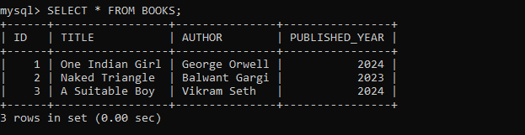

1. **Select only the title and author columns from the books table.**

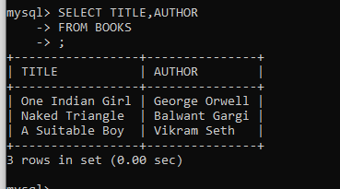

1. **Create a table named members with columns id, name, and membership_date.**



1. **Insert five records into the members table.**

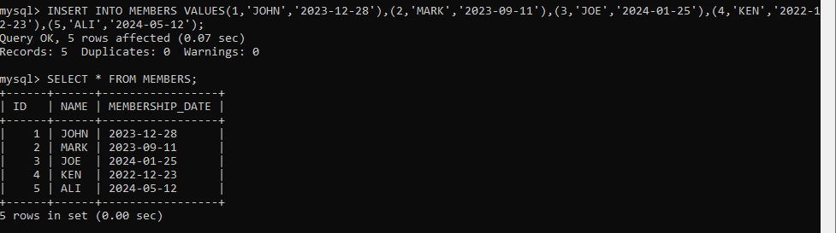

1. **Update the name of the member with id 2 to 'Jane Doe'.**

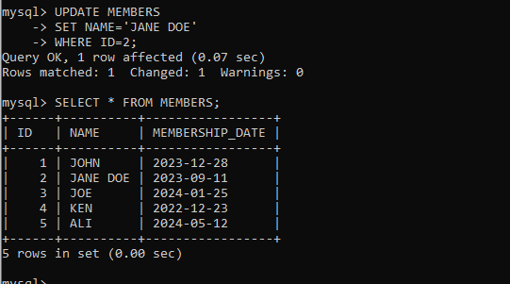

1. **Delete the member with id 5 from the members table.**

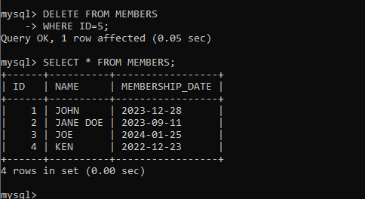

1. **Select all columns from the members table.**

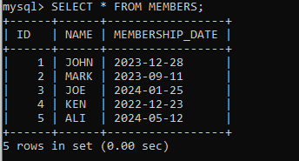

1. **Create a table named loans with columns id, book_id, member_id, and loan_date.**



1. **Insert three records into the loans table.**

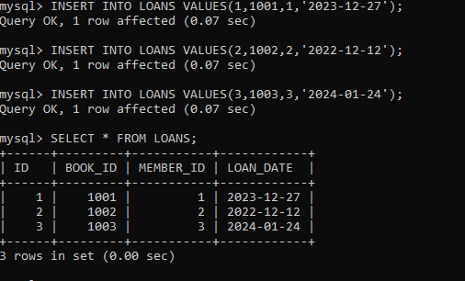

1. **Select all loans where the loan_date is after '2023-01-01'.**

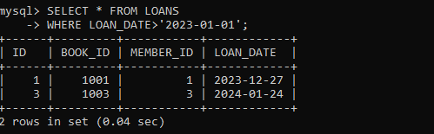

1. **Add a new column return_date to the loans table.**

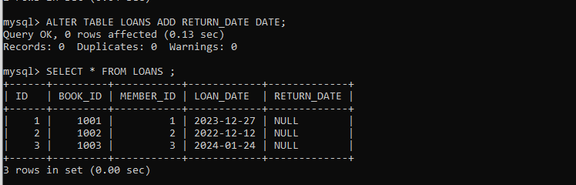

1. **Update the return_date for the loan with id 1 to '2023-06-01'.**

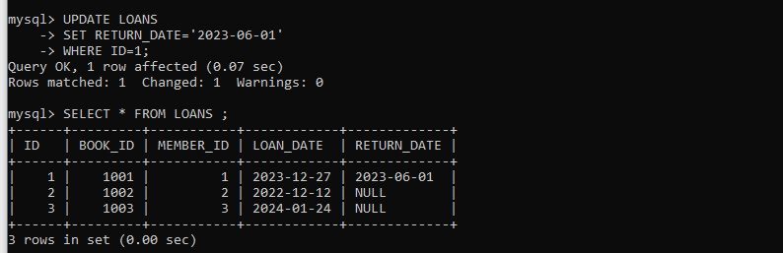

1. **Delete the loan with id 3 from the loans table.**

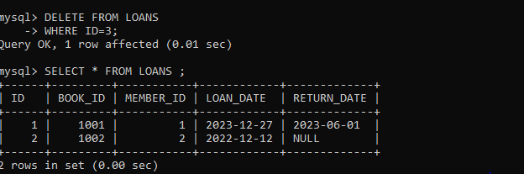

1. **Select all columns from the loans table.**

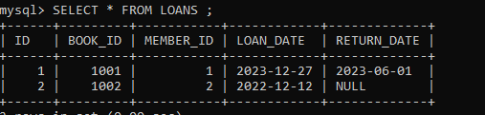

1. **Create a view named member_loans that shows the member's name and the titles of the books they have borrowed.**

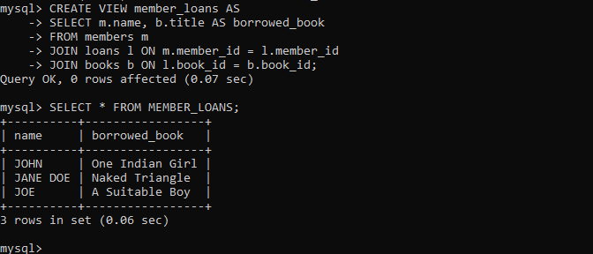

1. **Create a stored procedure named get_book_by_title that takes a title as input and returns the book details.**



1. **Create an index on the title column of the books table.**

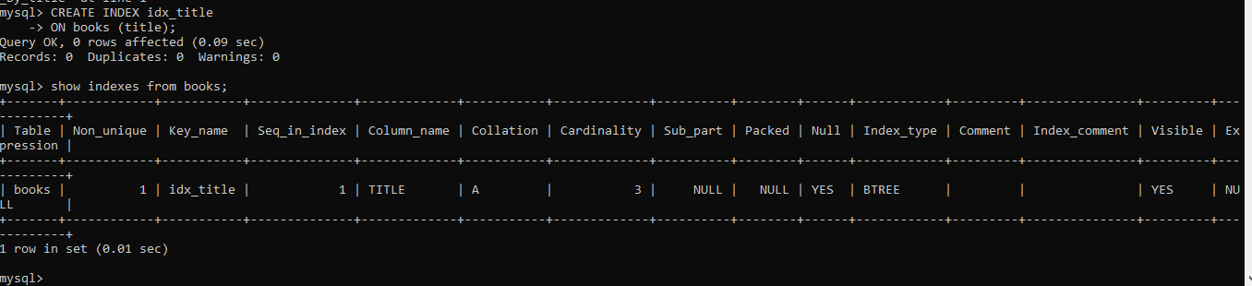

1. **Create a trigger that updates a last_updated column in the books table every time a record is updated.**

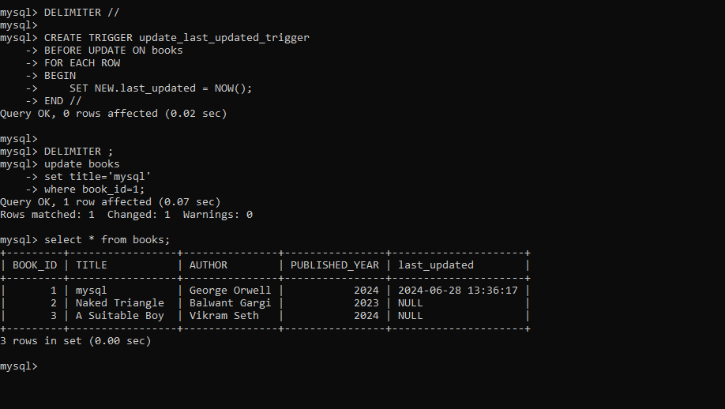

1. **Grant all privileges on the library database to a user named 'librarian' with password 'password123'.**

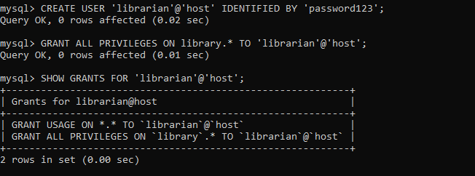

1. **Revoke the INSERT privilege on the books table from the 'librarian' user.**

